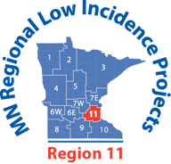

ASL Educational Interpreter Mentors
Community of Practice

February 22, 2022
4:30-6:30 p.m.
Note the Time Change

Virtual – Register in Advance to receive a Zoom Link

4:30 – 5:00 p.m. Introductions, Review of Agenda Items from 11.30.21, Planning for August 2022 workshop

5:00 - 6:30 p.m. Hilary Maag: A Fresh Look at Mentoring Interpreters
(Rescheduled from November 30, 2021)
.15 RID CEUs at the Some Content Knowledge level

Future Interpreter Meeting Plans:

August 2022 Back-to-School Workshop
September 20, 2022? Community of Practice Meeting

